Recent Research on Training AI with Noisy Image Data (up to 2025)
Researchers have begun to learn how to train image-generating AIs even when the training pictures are dirty, blurry, or partly missing. In simple terms, these studies show it helps if the AI sees a few clear (clean) images together with many noisy ones. The latest 2025 paper by Daras et al. confirms that mixing about 10% clear images with 90% noisy images lets the AI almost match the performance of using 100% clear images[1][2]. Below is a child-friendly summary of the main ideas from the key papers and how they relate:
- Daras et al. 2023 (Ambient Diffusion) – This was the first study to teach a diffusion-based AI to learn from only corrupted (noisy) images[3]. The idea was to add more noise during training and make the AI predict the original distorted image[4]. They tested on standard image datasets (like CelebA for faces, CIFAR-10 for objects, and AFHQ for animal faces)[5]. Even when 90% of each training image was missing or blank, the AI still learned to generate clean images with the right patterns[5]. This approach also had the bonus of not memorizing any exact image, since the model never saw any fully clean example[3]. (The code for this method is available on GitHub in the “ambient-diffusion” repository[6].)
- Daras et al. 2024 (Consistent Diffusion with Tweedie) – Building on the 2023 work, this paper solved how to exactly train a diffusion model on purely noisy data[7]. They used a math trick (double Tweedie’s formula and a “consistency” loss) to make the diffusion process correct for noisy inputs[7]. They fine-tuned a large Stable Diffusion model on noisy images and showed it still produced good-quality images while memorizing the training set much less[8]. (Their code “ambient-tweedie” is also public, and it lets you fine-tune diffusion models on Gaussian-noise-corrupted data[9].)
- Daras et al. 2025 (Ambient Laws) – This newest paper explored how much noisy data can replace clean data. They ran over 80 training experiments on image collections ranging from 30,000 to 1.3 million images[10]. They found that training with only noisy images cannot match training with clear images at those scales[1]. However, mixing them works very well: e.g., using 90% noisy + 10% clean gave almost the same image quality as 100% clean[1][2]. In other words, one clear image is worth about 1.5–1.75 noisy ones at the tested noise level[11]. They provide a neat result: at a noise of 14 dB SNR (fuzzy images), you need at most 1.75× as many noisy images to match clean-image training[11]. This is summarized in the table below (FID is a quality score; lower is better):
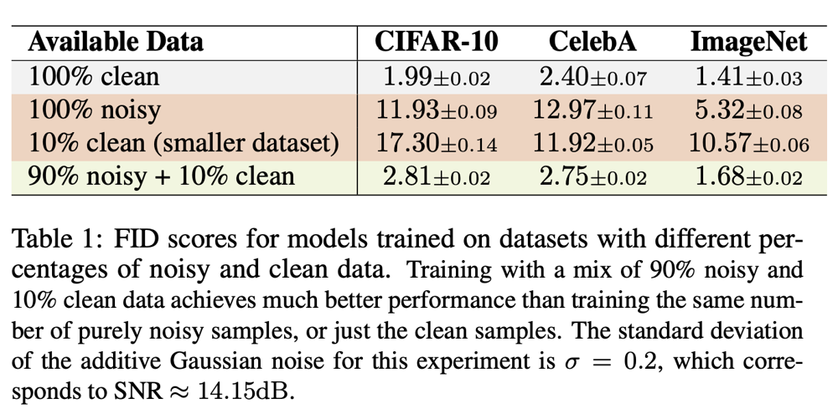
Figure: FID image-quality scores when training with different mixes of clean vs. noisy images (from Daras et al. 2025)[2][11]. 100% clean data gave FID=1.41 (best). Using 90% noisy + 10% clean gave FID=1.68, almost as good. Using only noisy images gave FID=5.32 (much worse).
These studies used datasets of real images (faces, objects, animals, etc.) and simulated noise by masking pixels or adding Gaussian blur. The 2023 and 2024 papers showed the AI can be trained with every image corrupted, as long as you add extra noise during training[3]. The 2025 paper used ImageNet-like data (many categories) and showed the combination strategy works across scales[10].
Limitations & Open Challenges: Current methods still need a lot of data and some clean examples. For example, even 2025’s best mix (10% clean) was tested on large datasets[1]. If you have no clean images at all, performance drops significantly[1]. Also, these methods assume certain noise types (e.g. Gaussian blur or random missing pixels). The math in Ambient Diffusion assumes the noise follows known rules (like inpainting or linear blur)[12], so it’s not guaranteed to work for arbitrary real-world noise (e.g. weird camera artifacts). Training also costs lots of compute (Daras et al. trained 80 big models)[13]. And while training on noisy data reduces memorization, very large models could still memorize patterns if noise is too low[8]. In short, we still need many images and careful design, and very noisy-only training does not reach “all-clean” quality[1].
Combining Ideas for Our Project: To meet our goal of learning from mixed-quality images, we can put these ideas together: - Gather a small clean set and a larger noisy set. Follow the 2025 finding: using ≈10% clean images and 90% noisy images often works best[1].
- During training, add extra corruption like in Ambient Diffusion. That is, randomly blur or mask parts of images and train the model to recover them[4]. This teaches the AI to handle even worse noise and focus on underlying patterns.
- Use the consistency loss / Tweedie method from 2024. In practice, we can fine-tune a strong diffusion model (like Stable Diffusion) on our noisy data using the publicly released code[9][6]. This helps the model learn the true clean data distribution and not memorize noise.
- Evaluate quality using FID or similar: check that adding a bit of clean data actually improves results (as shown in the 2025 table). Adjust the clean/noisy ratio if needed.
All the code is available to help. Daras and colleagues have GitHub repos for each approach (e.g. “ambient-diffusion”[6], “ambient-tweedie”[9], and “ambient-laws” from 2025). We can start from those implementations and adapt them to our data.
Sources: The above findings come directly from the latest research papers and their authors’ code. See Daras et al. (2023)[14][5], Daras et al. (2024)[7][8], and Daras et al. (2025)[10][2], all of which are summarized in the text above. These papers explain the data used, the problems solved, and the methods step-by-step for clarity.

[1] [2] [10] [11] [13] GitHub - giannisdaras/ambient-laws: [ICLR 2025]: How much is a noisy image worth?
https://github.com/giannisdaras/ambient-laws
[3] [4] [5] [6] [12] [14] GitHub - giannisdaras/ambient-diffusion: [NeurIPS 2023] Official Implementation: "Ambient Diffusion: Learning Clean Distributions from Corrupted Data"
https://github.com/giannisdaras/ambient-diffusion
[7] [8] [2404.10177] Consistent Diffusion Meets Tweedie: Training Exact Ambient Diffusion Models with Noisy Data
https://arxiv.org/abs/2404.10177
[9] GitHub - giannisdaras/ambient-tweedie: [ICML 2024]: Official implementation for the paper: "Consistent Diffusion Meets Tweedie"
https://github.com/giannisdaras/ambient-tweedie

